**Young's Experiment with Double-Slit**

The double-slit experiment is one of the best-known experiments in physics. It reveals with unprecedented interest that small particles of matter have a wave around them, leading to a dramatic impact on the action of a single particle. Imagine a wall on which there are two slits. Imagine casting balls of tennis on the wall. Some are bouncing off the wall, but some are jumping the slits (Ghalandari & Solaimani, 2020). If there is another wall behind the first, it will strike the tennis balls that traveled the slits. What do you expect to see if you mark all of the spots a ball has reached the second wall? That's right. That's right. Two strips colored approximately the same slit shape.

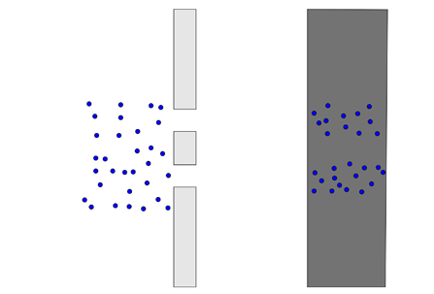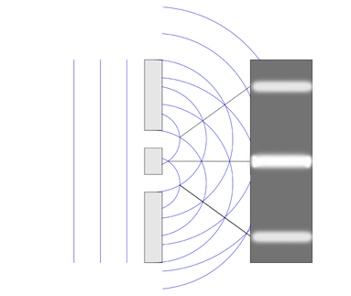

**Figure 2: An interference pattern**

**Figure 1: The pattern you get from particles.**

The famous double-slit experiment, also known as Young, was carried out by English scientist Thomas Young in the early 19th Century. The investigation shows that a beam of light, when separated into two beams, can exhibit interference results that can only be explained by the fact that light is an unusual disruption. Suppose light consisting exclusively of ordinary or classical particles is fired through the slit in a straight line with the permissible display on the other side. In that case, a pattern corresponding to the dimensions and shape of a slit is to be predicted (Sakai, 2018). However, the panel pattern is a diffraction pattern in which the light is scattered when this one-slope 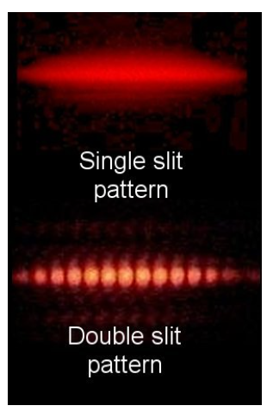experiment is completed. The narrower the slit, the wider the spreading angle.

**Figure 3: Young’s double slit experiment (if light was merely a photon, the interference pattern shown here would not be present).**

Likewise, if light consisted of classic particles and we were lighting two parallel slits, the predicted pattern would be a total of the two one-slit patterns on the screen. However, the pattern shifts to you in actuality, with various light and dark bands alternating. As Thomas Young showed this phenomenon, for the time being, it was seen that light consists of waves, which can be explained by the alternating "additivity" and "subtraction" of wavefront interference. The experiment, conducted at the beginning of the 1800s, played an essential role in accepting the wave light theory. It replenished Isaac Newton's corpuscular light theory, adopted in the 17th and 18th centuries, as a light propagation model (Sakai, 2018). Nearly a century later, in 1905, photo-electric research won by Albert Einstein's Nobel Prize showed that light could be composed of discreet particles under some conditions. These conflicting findings demanded that the quantum existence of light be taken care of outside classical physics.

**References**

Ghalandari, M., & Solaimani, M. (2020). Fractional Young double-slit numerical experiment with Gaussian wavepackets. *Scientific reports*, *10*(1), 1-13.

Sakai, K. (2018). Simultaneous measurement of wave and particle properties using modified Young's double-slit experiment. *Journal for Foundations and Applications of Physics*, *5*(2), 49-54.